**国际学术会议资助回国报销申请指南**

**Instruction on Reimbursement Application**

**因公出国(境)报销材料及常见问题请见Required documents and frequently asked questions on reimbursement application：<https://mp.weixin.qq.com/s/UG67INLG4fi39iB00gCuNg>**

资助申请获批的学生在参会回校后，应于会议结束后一个月内提交报销经费申请，流程如下：

The approved applicant should apply for the reimbursement within one month after the conference, process as follows:

1. 完成国际学术会议资助申请流程：登录数字交大http://my.sjtu.edu.cn—>待办事项，找到原国际会议资助申请，按要求上传材料。研究生院审核通过后，会进入制作经费单环节。**经费单制作约需5个工作日，完成后系统会发送通知邮件。**收到邮件后请至陈瑞球楼331领取经费报销单。（受理单位：研究生院国际化办公室 34207040）

Complete the *Financial Support Application for Attending International Academic Conference*: Log in “My SJTU” <http://my.sjtu.edu.cn> 🡪To-Do Tasks, find the original application, andupload the required documents. Upon approval by the graduate school, a reimbursement sheet will be prepared, which takes about 5 business days, and you will receive an auto email when the reimbursement sheet is ready to pick up at RM 331, Chen Rui Qiu BLDG. (Contact: International Affairs Office of Graduate School, 34207040)

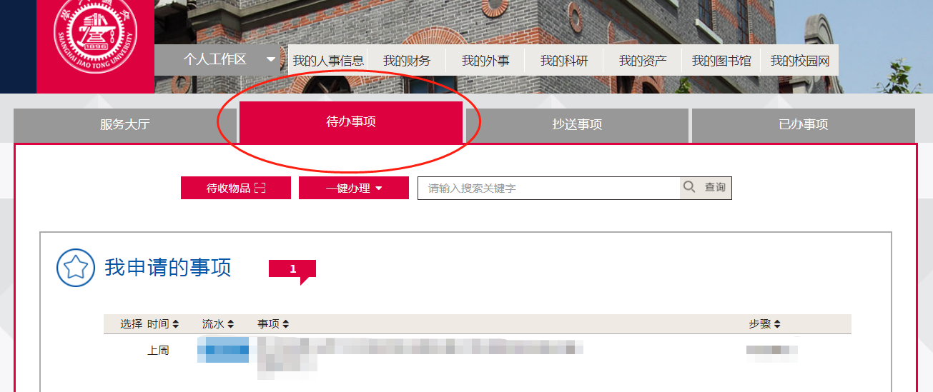

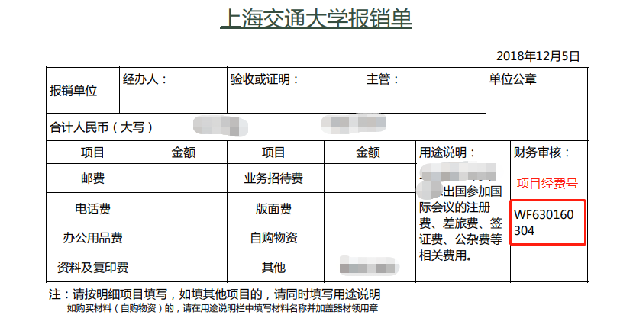

1. 完成因公出国（境）报销申请：登录数字交大<http://my.sjtu.edu.cn> ->服务大厅 -> 国际交流 -> 因公出国（境）报销申请 （受理单位：出入境管理与服务中心34207946）

Complete “因公出国（境）报销申请”: Log in “My SJTU” <http://my.sjtu.edu.cn> 🡪Service Hall🡪 Global Affairs🡪因公出国（境）报销申请 (Contact: Service Center for Exit-Entry Administration, 34207946)

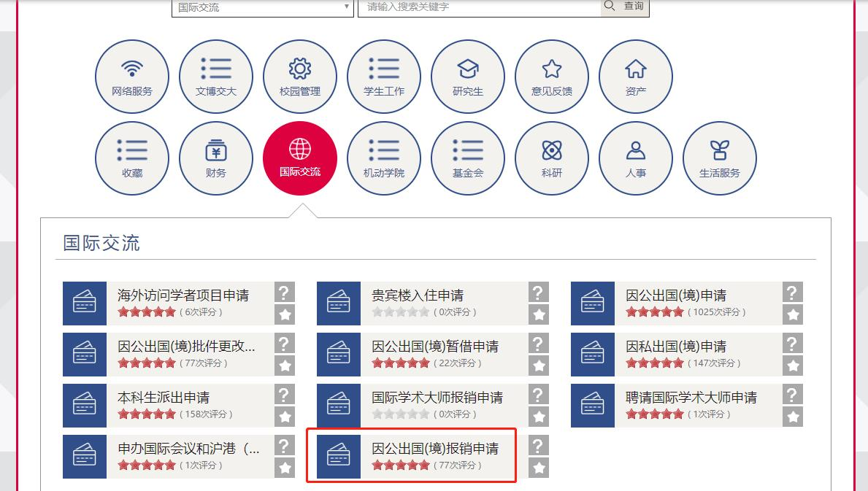

如需修改经费来源：服务大厅 -> 国际交流 -> 因公出国(境)批件更改申请 （受理单位：出入境管理与服务中心34207946）

If the funding source needs to be changed, please apply via: Service Hall🡪 Global Affairs🡪因公出国(境)批件更改申请 (Contact: Service Center for Exit-Entry Administration, 34207946)

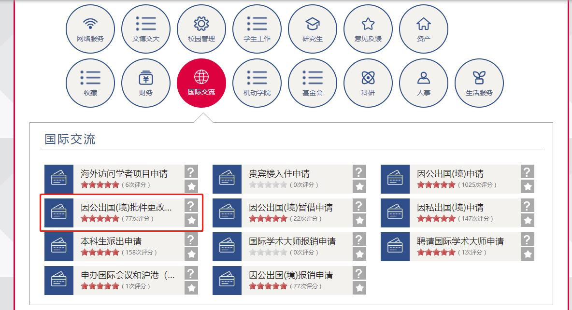

1. 因公出国（境）报销申请通过后，按邮件通知，点击财务预约，进入财务处网站完成预约报销（受理单位：财务计划处 34206610）

When the “因公出国（境）报销申请Reimbursement Application for Business international Trip”, an email should be sent to your email box. Please follow the instructions therein and click “财务预约Accounting Appointment” to complete the reimbursement application at the Financial & Planning Office website. (Contact: Financial & Planning Office website, 34206610)

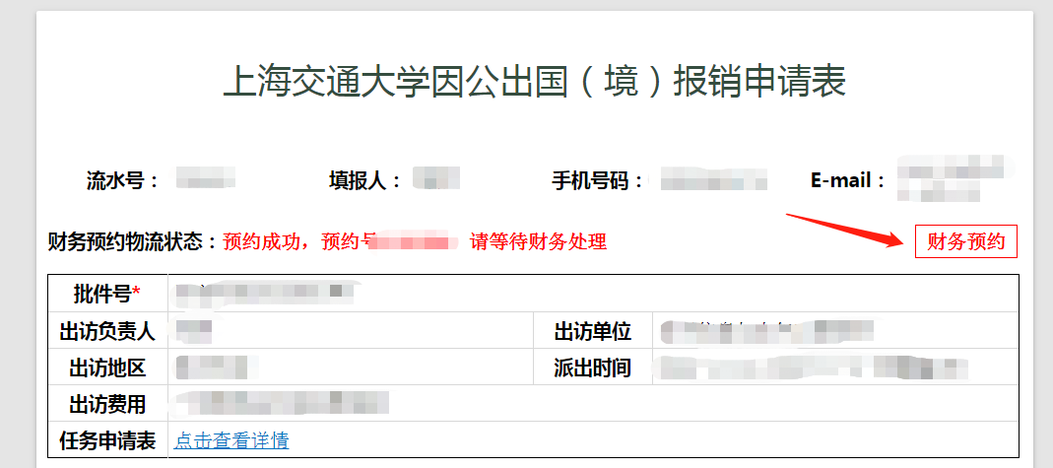

**若剩余费用由导师资助，请以导师的经费项目号预约全部费用，完成后打印预约单，完成签字盖章手续后，把研究生院提供的报销单附在报销材料中，一同送交财务处即可。**

If the supervisor sponsors the remaining costs, please fill in the Account Number of your supervisor’s project when making the appointment. Once completed, print the Appointment Form, have it signed and stamped, attach the reimbursement sheet issued by the Graduate School together with other necessary invoices/documents and submit to the Financial & Planning Office.

若剩余费用由本人自理，请以研究生院经费项目号（WF603160304）完成财务预约，打印预约单，签字后携预约单、所有票据及研究生院发放的经费单，至陈瑞球楼331申请盖章（需1-2个工作日）。盖章完毕后将所有材料送交财务处即可。

If the remaining costs is borne by the student, please fill in the Account Number （WF603160304）of the Graduate School when making the appointment. Once completed, print out the appointment form and have it signed, take the appointment form, all necessary invoices/documents, and the reimbursement sheet issued by the graduate school to Room 331, Chen Ruiqiu building to have the appointment form stamped (this might take about 1-2 working days). When it is done, please submit all the documents to the Financial & Planning Office.